Task 1:
lmf1<-lm(dat$Heel.Cracks~dat$Power+dat$Time+dat$Pressure+dat$LoopValue)
Call:
lm(formula = dat$Heel.Cracks ~ dat$Power + dat$Time + dat$Pressure +
dat$LoopValue)

Residuals:
Min 1Q Median 3Q Max
-0.11651 -0.06983 -0.03391 0.03963 0.26039

Coefficients:
Estimate Std. Error t value Pr(>|t|)
(Intercept) -0.9532375 0.2183215 -4.366 0.000332 ***
dat$Power 0.0059075 0.0008804 6.710 2.05e-06 ***
dat$Time 0.0016027 0.0008477 1.891 0.074002 .
dat$Pressure 0.0003308 0.0002527 1.309 0.206204
dat$LoopValue 0.0007357 0.0012317 0.597 0.557359
---
Signif. codes: 0 ‘***’ 0.001 ‘**’ 0.01 ‘*’ 0.05 ‘.’ 0.1 ‘ ’ 1

Residual standard error: 0.1069 on 19 degrees of freedom
Multiple R-squared: 0.719, Adjusted R-squared: 0.6598
F-statistic: 12.15 on 4 and 19 DF, p-value: 4.535e-05

lmf2<-lm(dat$Liftoff~dat$Power+dat$Time+dat$Pressure+dat$LoopValue)
Call:
lm(formula = dat$Liftoff ~ dat$Power + dat$Time + dat$Pressure +
dat$LoopValue)

Residuals:
Min 1Q Median 3Q Max
-0.216868 -0.136880 -0.001868 0.120038 0.233045

Coefficients:
Estimate Std. Error t value Pr(>|t|)
(Intercept) 0.9682748 0.3222206 3.005 0.00728 **
dat$Power -0.0081727 0.0012994 -6.290 4.88e-06 ***
dat$Time -0.0020621 0.0012511 -1.648 0.11574
dat$Pressure 0.0005915 0.0003730 1.586 0.12927
dat$LoopValue 0.0026860 0.0018178 1.478 0.15590
---
Signif. codes: 0 ‘***’ 0.001 ‘**’ 0.01 ‘*’ 0.05 ‘.’ 0.1 ‘ ’ 1

Residual standard error: 0.1577 on 19 degrees of freedom
Multiple R-squared: 0.7138, Adjusted R-squared: 0.6535
F-statistic: 11.84 on 4 and 19 DF, p-value: 5.37e-05

lmf3<-lm(dat$WireTear~dat$Power+dat$Time+dat$Pressure+dat$LoopValue)
Call:
lm(formula = dat$WireTear ~ dat$Power + dat$Time + dat$Pressure +
dat$LoopValue)

Residuals:
Min 1Q Median 3Q Max
-0.33238 -0.21092 0.00429 0.15177 0.30429

Coefficients:
Estimate Std. Error t value Pr(>|t|)
(Intercept) 0.9644860 0.4538226 2.125 0.0469 *
dat$Power 0.0023627 0.0018300 1.291 0.2122
dat$Time 0.0005458 0.0017620 0.310 0.7601
dat$Pressure -0.0009279 0.0005253 -1.766 0.0934 .
dat$LoopValue -0.0034432 0.0025602 -1.345 0.1945
---
Signif. codes: 0 ‘***’ 0.001 ‘**’ 0.01 ‘*’ 0.05 ‘.’ 0.1 ‘ ’ 1

Residual standard error: 0.2221 on 19 degrees of freedom
Multiple R-squared: 0.275, Adjusted R-squared: 0.1224
F-statistic: 1.802 on 4 and 19 DF, p-value: 0.1702

Lmf1
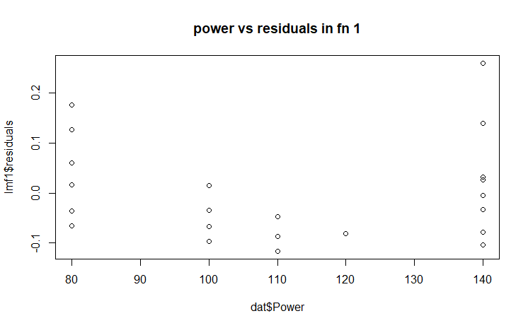
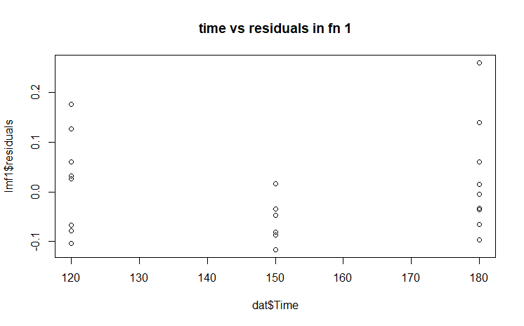
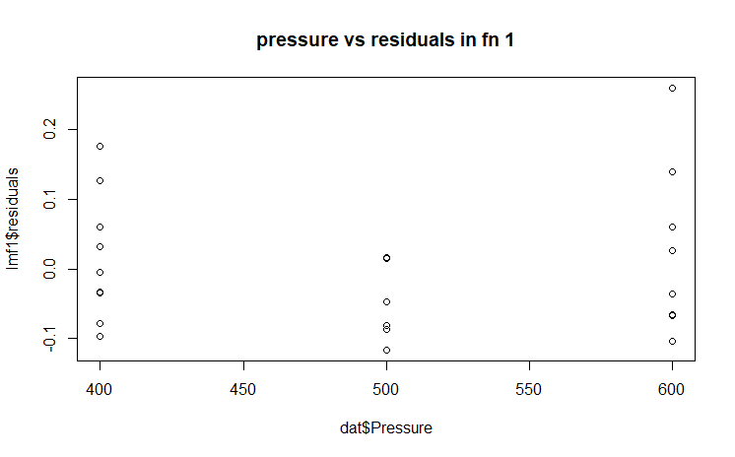
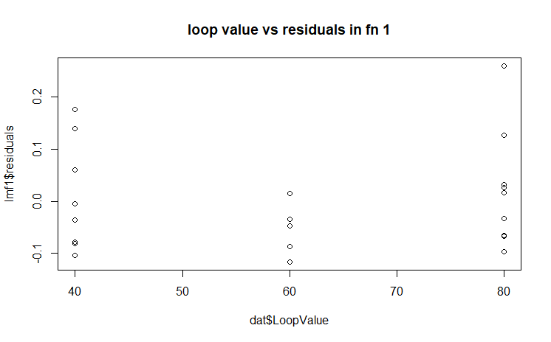

Plots for lmf2

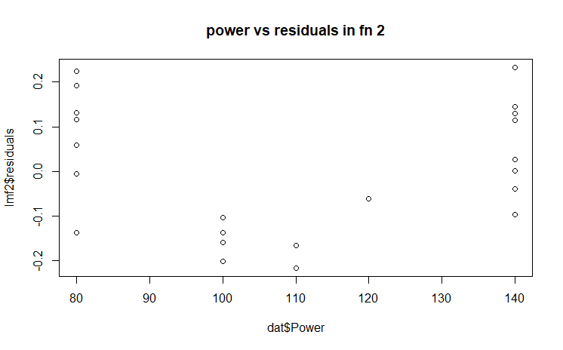
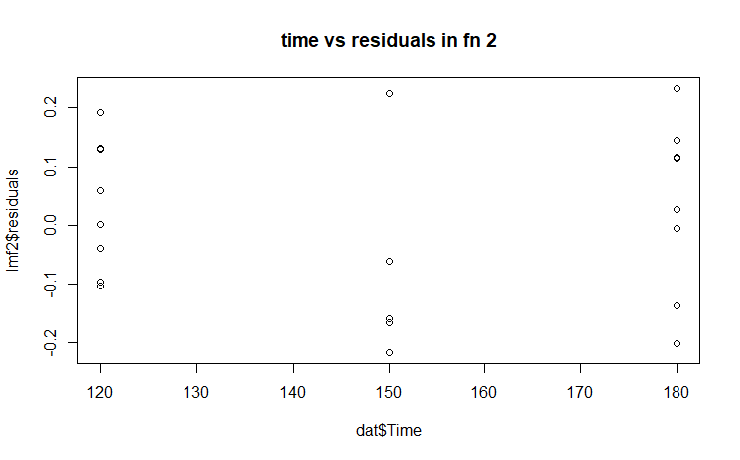
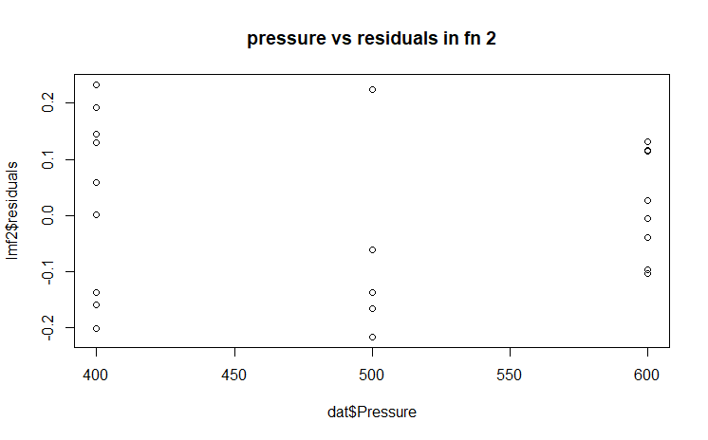
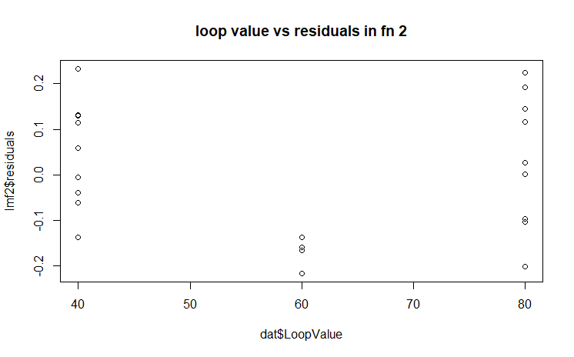

Plots for lmf3
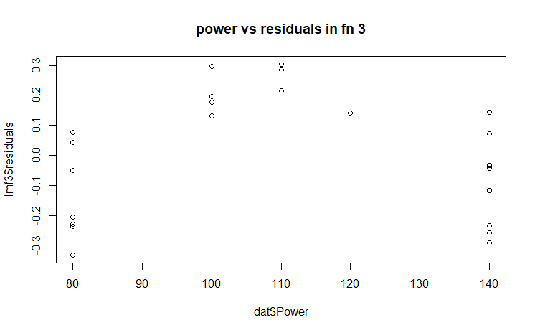
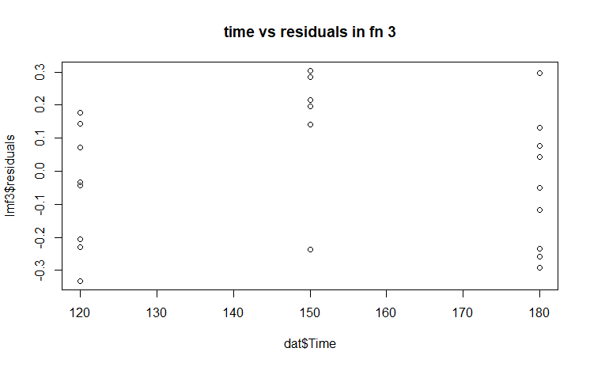
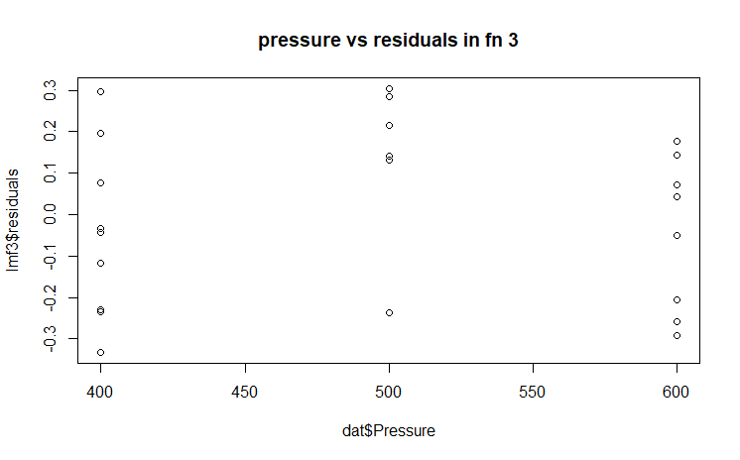
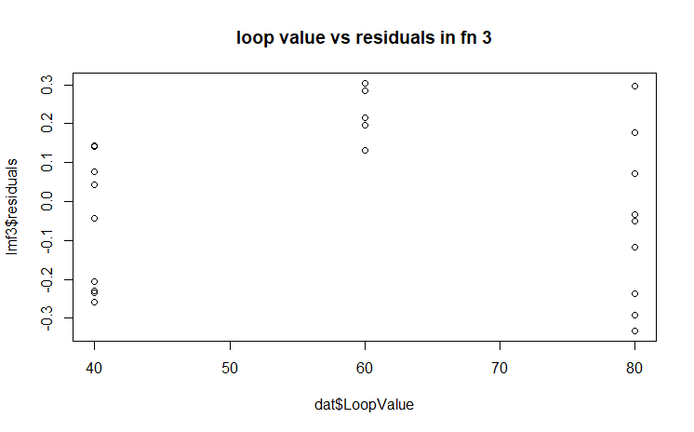

TASK 2
sqfm1<-lm(dat$Heel.Cracks~dat$Power+dat$Time+dat$Pressure+dat$LoopValue+I(dat$Power^2)+I(dat$Time^2)+I(dat$Pressure^2)+I(dat$LoopValue^2))
summary(sqfm1)
Call:
lm(formula = dat$Heel.Cracks ~ dat$Power + dat$Time + dat$Pressure +
dat$LoopValue + I(dat$Power^2) + I(dat$Time^2) + I(dat$Pressure^2) +
I(dat$LoopValue^2))

Residuals:
Min 1Q Median 3Q Max
-0.125672 -0.053590 -0.002656 0.026173 0.233306

Coefficients:
Estimate Std. Error t value Pr(>|t|)
(Intercept) 8.929e-01 1.433e+00 0.623 0.542
dat$Power -2.501e-02 1.906e-02 -1.312 0.209
dat$Time -1.207e-02 2.825e-02 -0.427 0.675
dat$Pressure 1.819e-03 8.366e-03 0.217 0.831
dat$LoopValue 1.614e-02 2.590e-02 0.623 0.542
I(dat$Power^2) 1.399e-04 8.651e-05 1.617 0.127
I(dat$Time^2) 4.541e-05 9.363e-05 0.485 0.635
I(dat$Pressure^2) -1.548e-06 8.403e-06 -0.184 0.856
I(dat$LoopValue^2) -1.266e-04 2.148e-04 -0.590 0.564

Residual standard error: 0.1032 on 15 degrees of freedom
Multiple R-squared: 0.7929, Adjusted R-squared: 0.6824
F-statistic: 7.178 on 8 and 15 DF, p-value: 0.0005749

sqfm2<-lm(dat$Liftoff ~dat$Power+dat$Time+dat$Pressure+dat$LoopValue+I(dat$Power^2)+I(dat$Time^2)+I(dat$Pressure^2)+I(dat$LoopValue^2))
summary(sqfm2)
Call:
lm(formula = dat$Liftoff ~ dat$Power + dat$Time + dat$Pressure +
dat$LoopValue + I(dat$Power^2) + I(dat$Time^2) + I(dat$Pressure^2) +
I(dat$LoopValue^2))

Residuals:
Min 1Q Median 3Q Max
-0.22660 -0.05523 0.01473 0.05398 0.15605

Coefficients:
Estimate Std. Error t value Pr(>|t|)
(Intercept) 2.335e+00 1.441e+00 1.621 0.12584
dat$Power -7.315e-02 1.917e-02 -3.816 0.00169 **
dat$Time 1.131e-02 2.841e-02 0.398 0.69616
dat$Pressure 7.723e-03 8.414e-03 0.918 0.37321
dat$LoopValue -2.126e-02 2.605e-02 -0.816 0.42718
I(dat$Power^2) 2.944e-04 8.701e-05 3.384 0.00409 **
I(dat$Time^2) -4.393e-05 9.417e-05 -0.467 0.64754
I(dat$Pressure^2) -7.296e-06 8.451e-06 -0.863 0.40156
I(dat$LoopValue^2) 2.033e-04 2.160e-04 0.941 0.36170
---
Signif. codes: 0 ‘***’ 0.001 ‘**’ 0.01 ‘*’ 0.05 ‘.’ 0.1 ‘ ’ 1

Residual standard error: 0.1038 on 15 degrees of freedom
Multiple R-squared: 0.902, Adjusted R-squared: 0.8498
F-statistic: 17.27 on 8 and 15 DF, p-value: 2.919e-06

sqfm3<-lm(dat$WireTear ~dat$Power+dat$Time+dat$Pressure+dat$LoopValue+I(dat$Power^2)+I(dat$Time^2)+I(dat$Pressure^2)+I(dat$LoopValue^2))
summary(sqfm3)
Call:
lm(formula = dat$WireTear ~ dat$Power + dat$Time + dat$Pressure +
dat$LoopValue + I(dat$Power^2) + I(dat$Time^2) + I(dat$Pressure^2) +
I(dat$LoopValue^2))

Residuals:
Min 1Q Median 3Q Max
-0.200932 -0.085977 -0.000113 0.076596 0.206952

Coefficients:
Estimate Std. Error t value Pr(>|t|)
(Intercept) -2.298e+00 2.056e+00 -1.117 0.28137
dat$Power 9.883e-02 2.735e-02 3.613 0.00256 **
dat$Time -4.686e-04 4.054e-02 -0.012 0.99093
dat$Pressure -9.111e-03 1.201e-02 -0.759 0.45974
dat$LoopValue 5.460e-03 3.717e-02 0.147 0.88517
I(dat$Power^2) -4.369e-04 1.242e-04 -3.518 0.00310 **
I(dat$Time^2) 2.879e-06 1.344e-04 0.021 0.98319
I(dat$Pressure^2) 8.408e-06 1.206e-05 0.697 0.49640
I(dat$LoopValue^2) -7.971e-05 3.083e-04 -0.259 0.79953
---
Signif. codes: 0 ‘***’ 0.001 ‘**’ 0.01 ‘*’ 0.05 ‘.’ 0.1 ‘ ’ 1

Residual standard error: 0.1482 on 15 degrees of freedom
Multiple R-squared: 0.7453, Adjusted R-squared: 0.6094
F-statistic: 5.485 on 8 and 15 DF, p-value: 0.002322

Center point alarm: you mentioned something like this in class once, I am not sure if it is correct, I might be mistaken.
In the graph plot of residuals vs fitted values for a linear model, if the observations follow this pattern
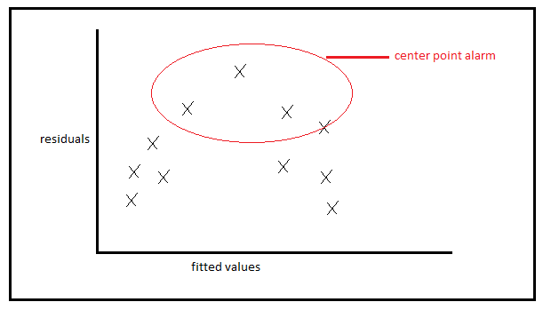
This means the residuals are not evenly distributed like they should be for error values to occur independently. But as we see a pattern here among the the points plotted, we must introduce a square term to the model. I have introduced square term in the answers below and plotted the plots for both cases (plots that show center point alarm vs the plots obtained after introduction of square term that show dispersed residuals) and displayed side by side for comparison.

Comparing whether introduction of square term improves the model corresponding to component vs residual plot

For function 3: wire tear in power component
Before introducing sq term | After introducing sq term
 | 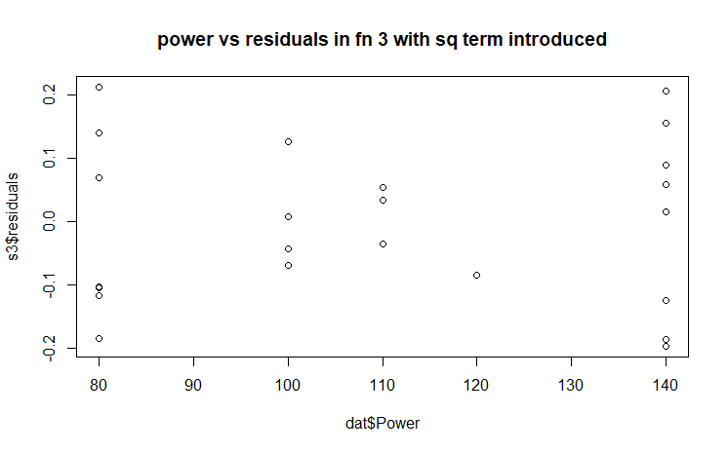

For function 3: wire tear in time component

Before introducing sq term | After introducing sq term
 | 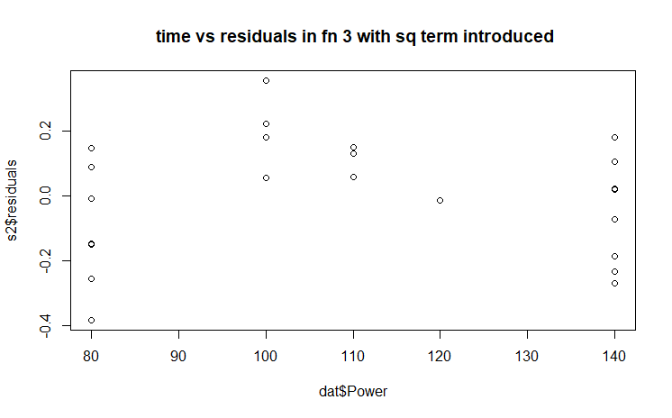

For function 3: wire tear in pressure component

Before introducing sq term | After introducing sq term
 | 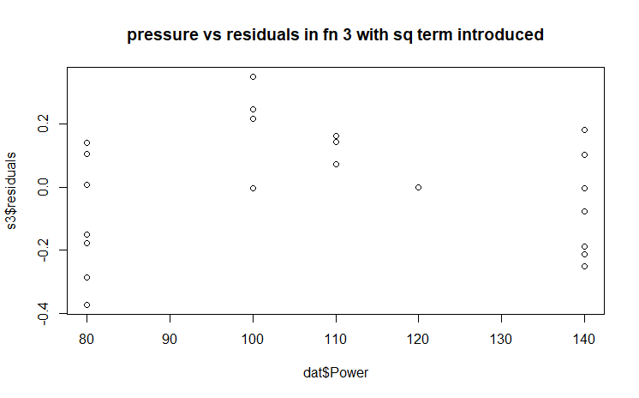

For function 3: wire tear in loop value component

Before introducing sq term | After introducing sq term
 | 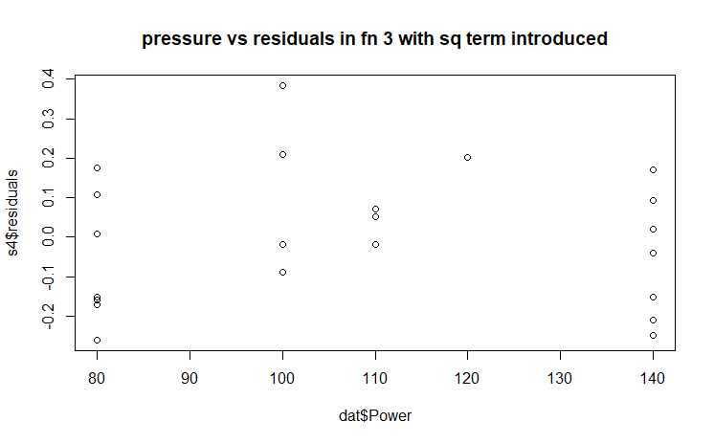

Residuals vs fitted values plot for square models
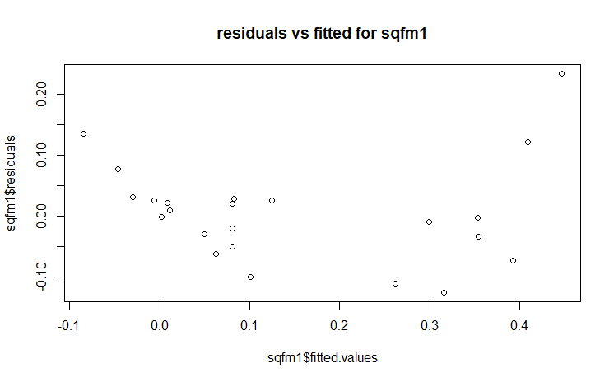
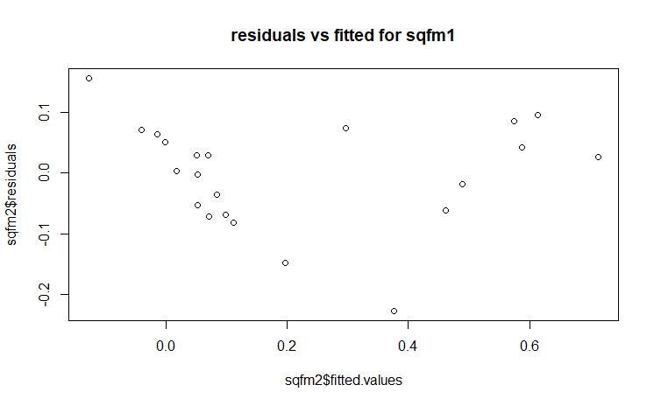
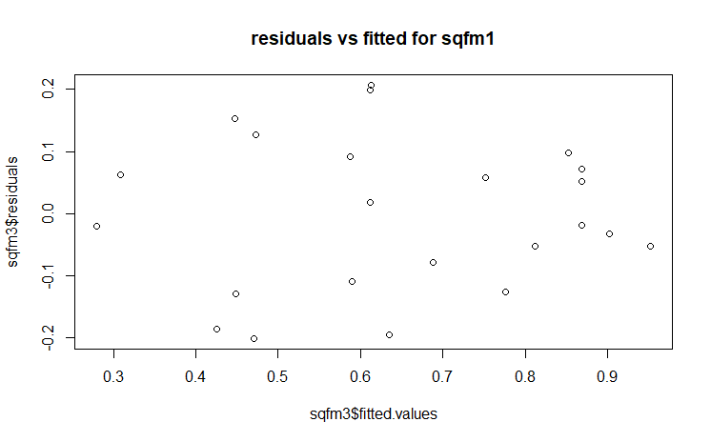

TASK 4
 |  | heelcracks
 |  | low(0-0.2) | high(0.2-1) | total
power | low(80-100) | 12 | 0 | 12
 | high(120-140) | 3 | 6 | 9
 | total | 15 | 6 | 21

Pr=15/21 * 100= 0.71
 |  | heelcracks | s=0.1
 |  | low(0-0.1) | high(0.1-1) | total
power | low(80-100) | 11 | 1 | 12
 | high(120-140) | 0 | 9 | 9
 | total | 11 | 10 | 21

Pr=0.52
 |  | heelcracks | s=0.3
 |  | low(0-0.3) | high(0.3-1) | total
power | low(80-100) | 12 | 0 | 12
 | high(120-140) | 4 | 5 | 9
 | total | 16 | 5 | 21
Pr=0.76
 |  | heelcracks | s=0.4
 |  | low(0-0.4) | high(0.4-1) | total
power | low(80-100) | 12 | 0 | 12
 | high(120-140) | 7 | 2 | 9
 | total | 19 | 2 | 21
Pr=0.90
Table of cutting point with sensitivity and specificity
Cutting point | Sensitivity | specificity | 1-specificity
0.1 | 1 | 0.9 | 0.1
0.2 | 0.8 | 1 | 0
0.3 | 0.75 | 1 | 0
0.4 | 0.63 | 1 | 0

